Page 3  3. Pre-installation Tasks  Ask the technical contact to perform the following tasks in order to prepare the company’s network for the initial configuration:  - Media Type – The port on the network switch that is connected to the Filer’s built-in Ethernet port should be configured to the same speed as the Filer. Most network switches have all ports set to ‘auto-negotiate’ by default - which has been known to cause problems. Setting both the network switch and the Filer to static settings is the best practice.  - Email Server – A company’s email server may be outside the organization or on the public Internet side of a security firewall. The technical contact will need to make sure that the Filer is able to send email freely to the Internet by contacting the email or security administrator for additional configuration.  You must establish a console terminal connection in order to perform the initial setup script. This requires a serial cable connection to a Windows PC or Server and configuration of HyperTerminal Software.  - Console Cable Connection – Each Network Appliance Filer ships with a 25 ft. gray console cable. Connect one end to the Console port on the back of the Filer (shown in Figure 1). Connect the other end to the serial port on the back of a nearby server or portable laptop computer.  - Configure HyperTerminal – Use the Windows-based terminal client, which can be found under ‘Accessories’ on the ‘Start’ menu. Create a new connection with the following settings:  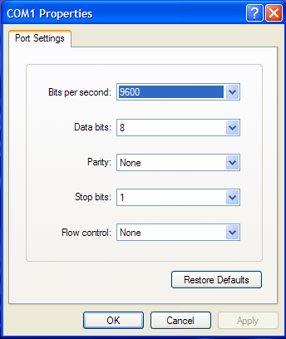  Figure 2. HyperTerminal Settings Window | Page 4  4. Initial Configuration  With the HyperTerminal software connected at a PC you are now ready to start the configuration.  - Start up the Filer by powering on each of any external disk shelves and waiting approximately 15 seconds for all drives to spin up.  - Next, turn on the Filer’s CPU by flipping both switches on the back of the Filer near each of the power cords.  - Within the HyperTerminal window text will show the Filer starting by showing the OS version and counting up the amount of main memory.  - After discovery of all devices, the setup script will then start by showing some instructions followed by the prompt ENTER HOSTNAME:  - Enter the host name given during the Interview process. The remaining prompts ask for the information in the same order gathered at interview.  - Once you have entered all information through the end of the section labeled AUTOSUPPORT INFORMATION, the Filer will reboot itself.  5. Windows Network Configuration  After about 10 seconds you will see the startup routine repeat in the HyperTerminal window. Watch until you see the HOSTNAME> prompt.  - You will now be able to complete the configuration process through a web browser. Open the browser application and browse to the site:  http://ip_address/na_admin  where ip_address was gathered under NETWORK INFORMATION.  - Enter the password when prompted.  - Click on the icon ‘CIFS Configuration’. There will be several text boxes prompting for the information gathered under MICROSOFT WINDOWS INFORMATION. Enter the appropriate information.  - Click on the icon ‘Start CIFS’. When you see the confirmation that the Filer is ready, it will act as any Windows file server on the network.  You may restart the configuration process (at Step 4 above) at any time by typing setup in the HyperTerminal window.  6. Contacting Technical Support  - Look at the DataWise internal document Network Appliance Quick Troubleshooting Guide (if available)  - Contact DataWise Sr. Engineer – Tom Heffron at 913-555-XXXX x125.  - Contact Network Appliance S.E. – Jerry Eagle at 314-555-1234.  - Contact Network Appliance P.S.E – Rick McCague at 708-555-1234.  - Contact Network Appliance Technical Support Line at 1-888-4NETAPP (1-888-463-8277) to open an incident call.  NOTE: You must have the Filer’s serial number gathered in FILER INFORMATION before calling this number.  NOTE: Make sure you write down the incident number provided.

