Page 1  Initial Configuration Checklist (Quick Setup)  Use these instructions when configuring a Network Appliance Filer (Models F87, F810, F820, F840) using ONTAP operating system version 6.0 or later. These steps are designed for a typical initial setup that will allow the Filer to communicate over the network and begin serving data as quickly as possible. Additional administration will be needed for performance, tuning, and added options.  Summary:  - Pre-configuration Interview  - Physical Installation Check  - Pre-configuration Tasks  - Initial Configuration  - Windows Network Configuration  - Contacting Technical Support  1. Pre-configuration Interview  Gather the following information from the customer’s main technical contact prior to arriving on site for installation. Answers will be specific to their environment and will be needed for the setup script that runs when the Filer is turned on for the first time.  FILER INFORMATION  - MAC address – from Filer’s built-in Ethernet interface.  - Serial number – found on back of Filer above the ‘console’ port.  NOTE: This number can also be found on shipping paperwork.  - Host name – this will identify the Filer on the company’s network.  NOTE: This name must start with a letter and cannot be longer than 15 characters. (example – FILER01)  - Password – used for administrative access to the Filer.  - Time Zone – usually ‘America/Chicago’ (see Admin Guide for others)  - Filer Location – a short description of the Filer’s physical location.  - Language – usually ‘en_US’ (see Admin Guide for others)  - Admin Host – IP address of host with full access to the Filer.  NETWORK INFORMATION  - Interface Name – we will focus on Ethernet interface ‘e0’. This is the Filer’s built-in 10/100Mbps interface. Others will be configured later.  - IP Address – must be dedicated and unique for each interface.  - Subnet Mask – IP network section (example – 255.255.0.0)  - Media Type – usually ‘100tx-fd’ (see Admin Guide for others)  NOTE: See ‘Pre-configuration Tasks’ for additional information.  - Default Gateway – name and IP address of first-hop gateway.  - Internet Naming Services – domain (xyz.com) and IP address. | Page 2  AUTOSUPPORT INFORMATION  - Email Address – this is the address that will appear in the ‘From:’ block in any email sent to Network Appliance Technical Support. This is the address that will receive any response from the support team if additional information is requested.  - Email Server – IP address of the company’s email server.  NOTE: See ‘Pre-configuration Tasks’ for additional information.  MICROSOFT WINDOWS INFORMATION  - Windows Domain Name – server set used for authentication.  - Windows Domain Controllers – server names and IP addresses.  - WINS Servers – if used in the customer’s environment.  - Local Windows Username and Password – for default access.  2. Physical Installation Check  The full details of installation can be found in either the F87 Hardware Guide or the F800 Series Hardware Guide. However, refer to Figure 1 while making these quick verifications that can save time during the setup script:  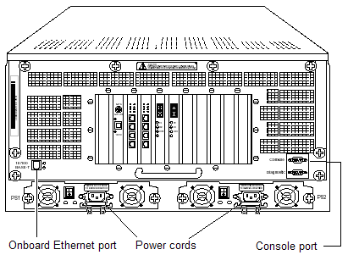  - Check that all power cords are secured with locking brackets.  - Check that only the built-in Ethernet port is connected to a working network device allowing communication to the general network.  - Since disk drives can shift during shipping, remove and firmly reseat each drive in the front of each drive shelf.  NOTE: This process should be done while power is OFF.  WARNING: Do not ‘SLAM’ the drives into the shelf – it may damage the connections in the drive or the shelf unit.  Figure 1. View of back of F800 Series Filer

