Thomas Heffron
Assignment #4 – Chapter 5
Due Date: 9 Jul 2002
CS481, Inst.: Dr. Stach

Problem #5.1.
Fault: RegDst = 0
Result:
- R-type instructions that do not store the result in the rt register will not work properly. In other words, the rd register can never be asserted.
- This will not effect the lw, sw, and beq instructions.

Fault: ALUSrc = 0
Result:
- lw and sw instructions will not work properly since the memory offset in bits 0-15 is never asserted. The ALU result to the data memory address will be the value of rs+rt, which will probably not be the value desired.
- R-type and beq instructions will not be effected.

Fault: MemtoReg = 0
Result:
- lw instruction will not work properly since the data read from memory can never be asserted and stored in the register. The register will actually hold the address of the desired information.
- R-type, sw, and beq instructions will not be effected.

Fault: Zero = 0
Result:
- The program cannot branch. It will only progress through the set of instructions sequentially. A beq (j also) cannot be asserted.
- R-type, sw, and lw instructions will not be effected.

Thomas Heffron
Assignment #4 – Chapter 5
Due Date: 9 Jul 2002
CS481, Inst.: Dr. Stach

Problem #5.5.
There are no additional data paths needed to implement the addi instruction. It is an I-type instruction with an Opcode of 8_{ten}. All we need to do is add (by changing the PLA) that Opcode to create the appropriate ouput from the Control Unit:

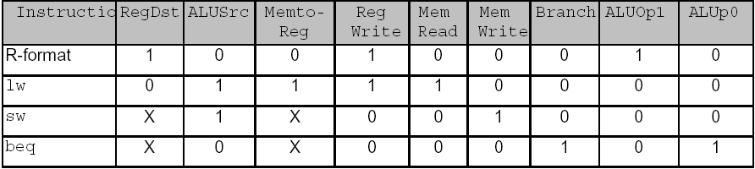

addi 0 1 0 1 0 0 0 0 0

RegDst = 0 to put the result in register rt
ALUSrc = 1 to present the sign extension of bits 0-15 to the 2nd operand of the ALU
MemtoReg = 0 since we are not transferring from memory
RegWrite = 1 since we want to store the result in a register
MemRead = MemWrite = 0 since this is not a memory instruction
Branch = 0 since this is not a branch instruction
ALUOp1 = ALUOp0 = 0 which sets the ALU control to add.

